# Diagram layout and generation tools

* [Go JS (commercial)](http://gojs.net/latest)
* [PlanText online editor for PlantUML](http://www.planttext.com/planttext)
* [MediaWiki](https://www.mediawiki.org/w/index.php?title=Special:Book&bookcmd=book_creator&referer=Manual%3AContents)

# A sample large image

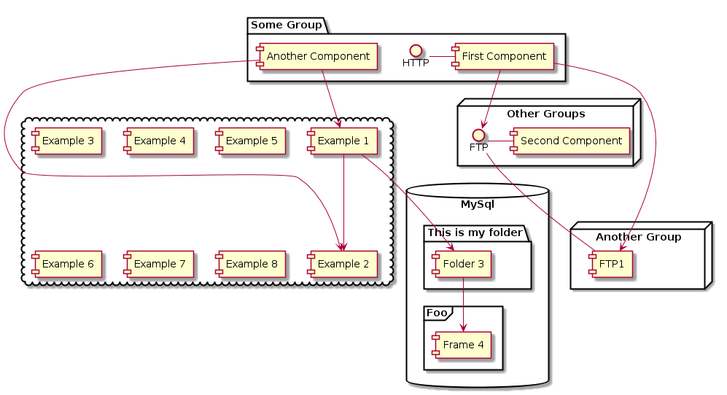

large image



large image